Contemporaneous Notes

Examiner | Alish Mahat | Exam commenced | 01/01/2026
Other relevant information |  | Software used, versions and licensing | Autopsy (4.21.0)  Regripper(4.0)  AcessData FTK imager (3.1.2.0)  Windows powershell
Note: This document forms the scope of your investigation, the Officer In Charge wants these areas examined. If you decide to omit a process, then you should provide your reasons for doing so here and in your statement. You may add additional rows, as appropriate.

Action | Done? | Date | Time | Notes
Load case and verify image | Yes | 01/01/2026 | 6:30 am | 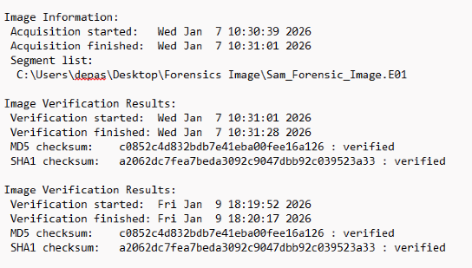  First checked the hash given with the e01 file  Autopsy > New Case > Load image E01. Set timezone. Verified MD5/SHA hash using 'Data Source Integrity' module.  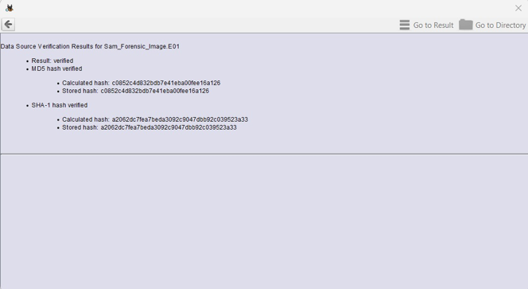
Load Case into second forensic tool for dual verification of at least 2 key artefacts, evidence items | Yes | 01/01/2026 | 6:43 am | 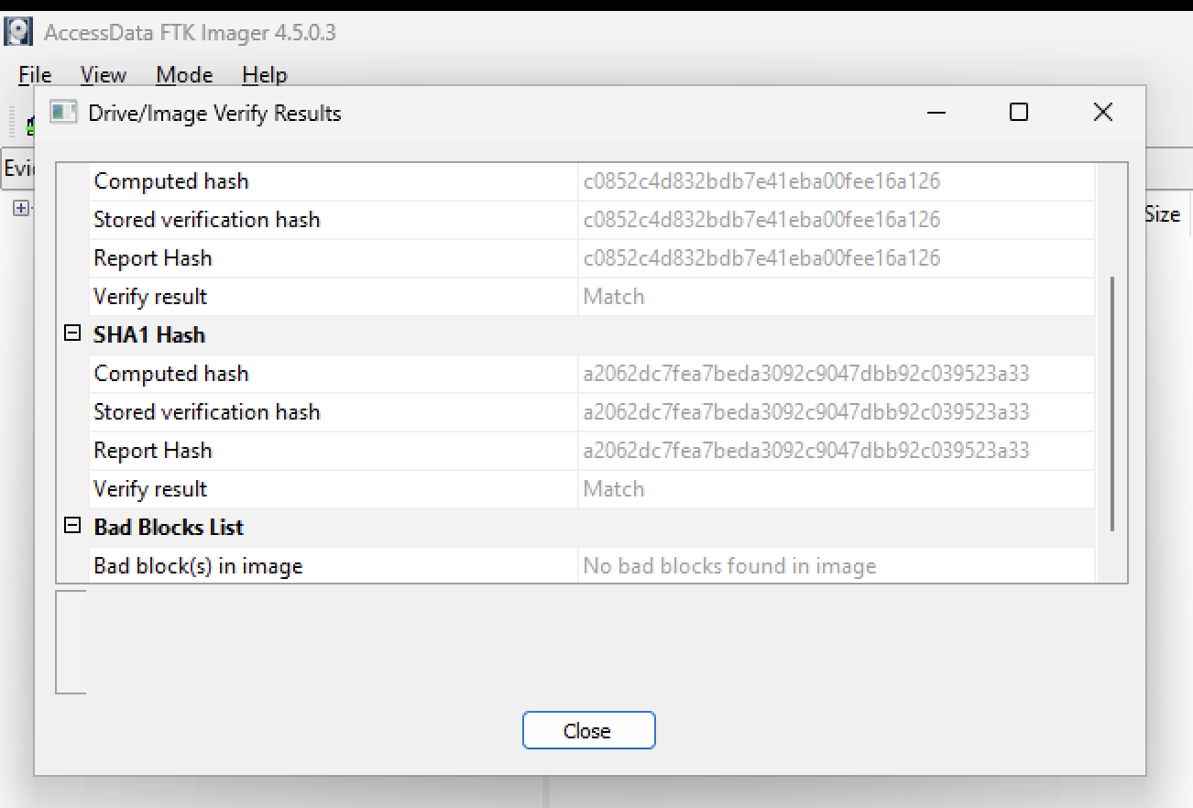  using AcessData FTK imager to matched hash value and MD5.  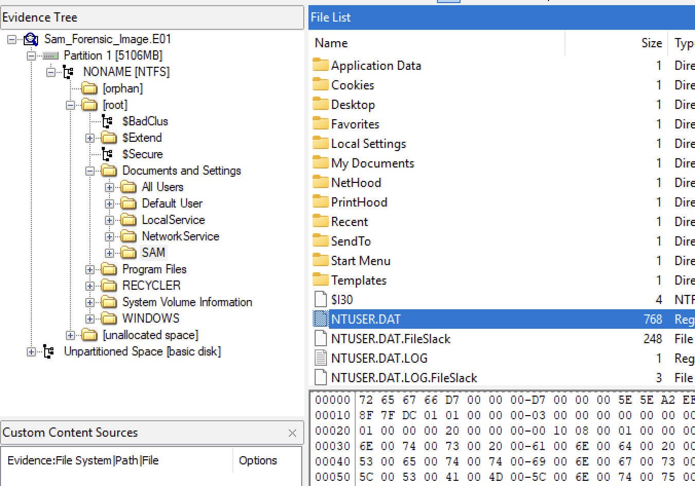  - Utilized FTK Imager to examine the NTUSER.DAT file.  - Extracted relevant information from the NTUSER.DAT file using FTK Imager.
Time Zone Adjusted?  Report Time Zone used for Analysis. | Yes | 01/01/2026 | 7:07 am | 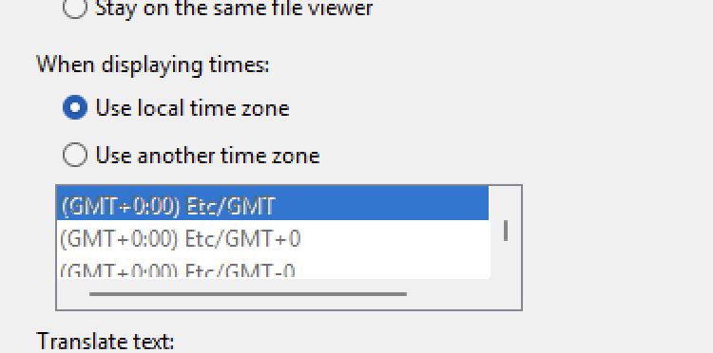  - In Autopsy, go to Tools > Options > Timezone  - Confirmed GMT+00:00 UTC is selected
Recover lost folders  (NTFS, FAT16&32). | Yes | 01/01/2026 | 7:35 am | check Views > File Types > Deleted  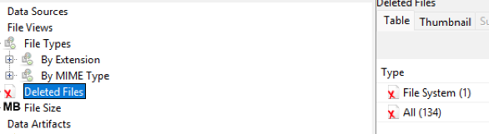
Mount archives;  zip, thumbs.db, etc. | Yes | 01/01/2026 | 7:44 am | - Go to Data Artifacts > File Types > Archives  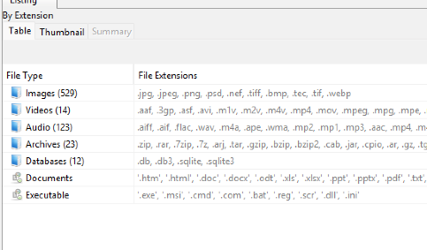  - Filter .zip, .rar, .thumbs.db
File signature analysis (any interesting file mismatch?);  Compute hash values (enable entropy computation) | Yes | 01/01/2026 | 7:57 am | Go to Analysis Results> Extension Mismatch Detector  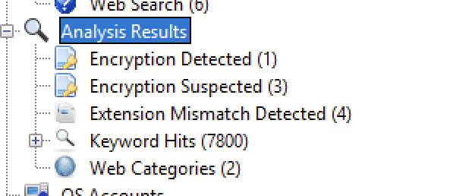
Internet History, favourites, etc.  Other browsers? | Yes | 01/01/2026 | 8:13 am | 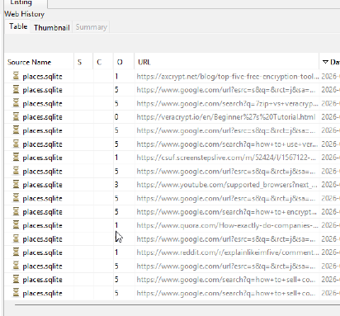  Go to Data Artifacts > Web History
Emails, local and web-based. | Yes | 01/01/2026 | 8:20 am | 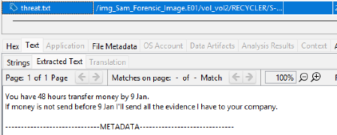  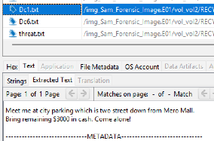  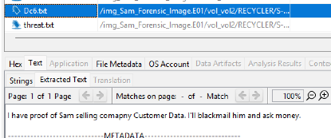  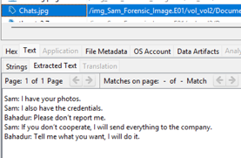  No emails found but some local message draft wore found in text form
Retrieve operating system information, accounts information, software, time zone information etc.). | Yes | 01/01/2026 | 9:30 am | - Open SYSTEM, SAM, SOFTWARE, SECURITY hives from Data Artifacts  - path: " WINDOWS/system32/config  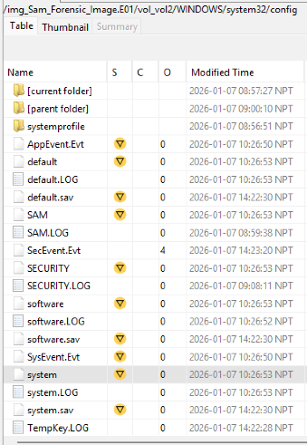  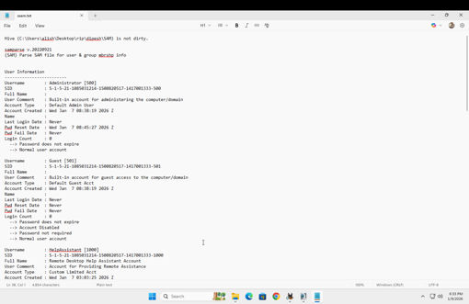  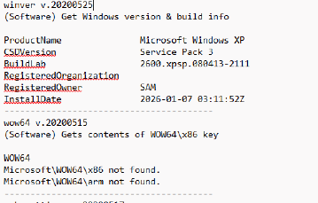  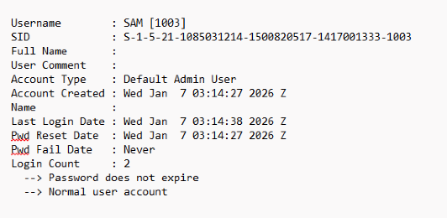  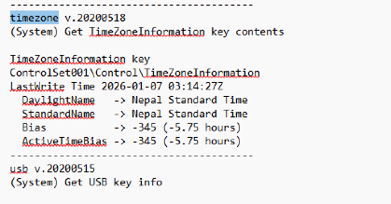  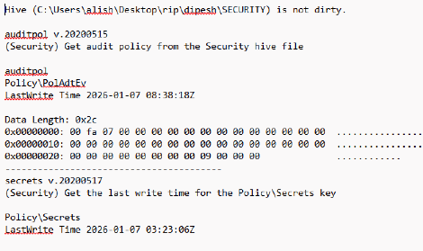  - SAM hive was analyzed, the username is “SAM”  - No password is required to access the user.  - SYSTEM hive was analyzed, the timezone of the device is NPT.  The SOFTWARE hive was analyzed, the OS of the device is Windows XP
Timeline analysis-  Note date of last activity on the computer. System profiling. | Yes | 01/01/2026 | 10:11 am | 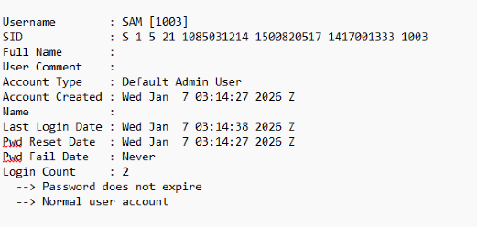  Last logon date: wed jan7 3:14:38 2026 NPT
Registry analysis and  Registry protected area | Yes | 01/01/2026 | 10:23 am | - SAM, SYSTEM, SECURITY and SOFTWARE hives have already been analyzed.  - Utilized RegRipper to analyze the extracted registry hives.  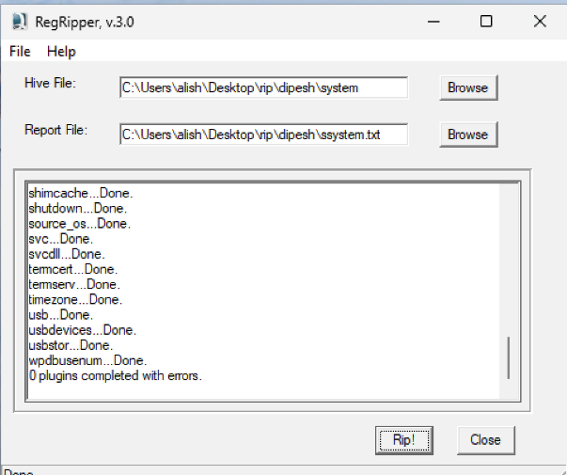
Link files and Recycle Bin | Yes | 01/01/2026 | 11:11 am | 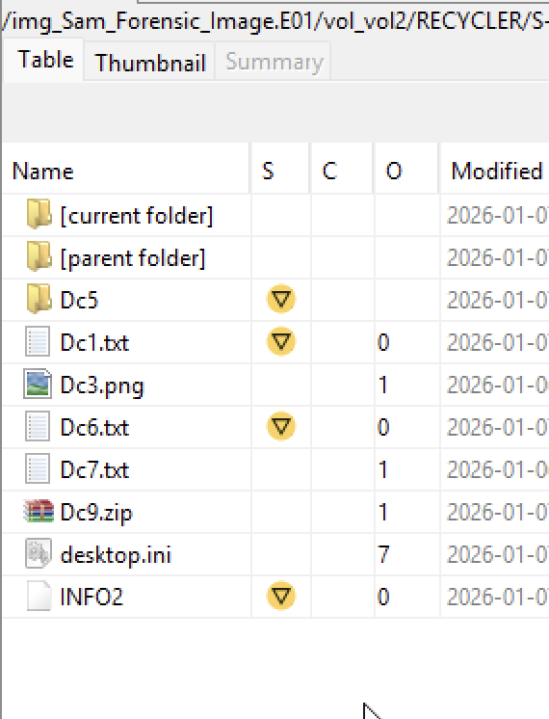  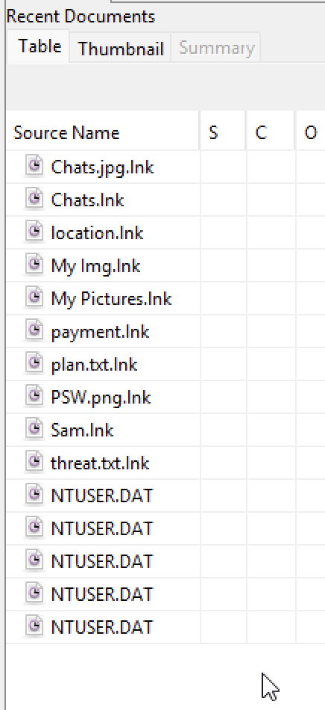  - Data Artifacts > Recycle Bin, Recent Documents  - Path:RECYCLER
Instant Messaging clients | Yes | 01/01/2026 | 11:30 am | 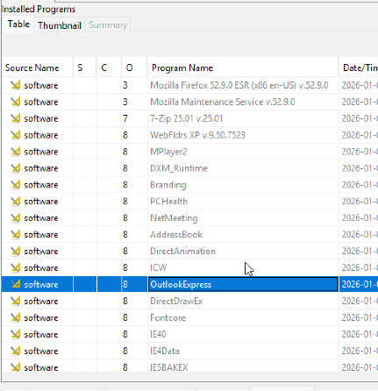  - Data Artifacts > Installed Programs  Email client outlookexpress was found
Clean-up/Wiping utilities. Check log files. Anything used? | Yes | 01/01/2026 | 12:00 pm | 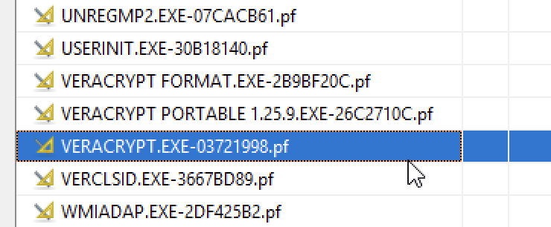  - Data Artifacts > Run Programs  Veracrpyt was seen
External drives; Network connections | Yes | 01/01/2026 | 12:15 pm | 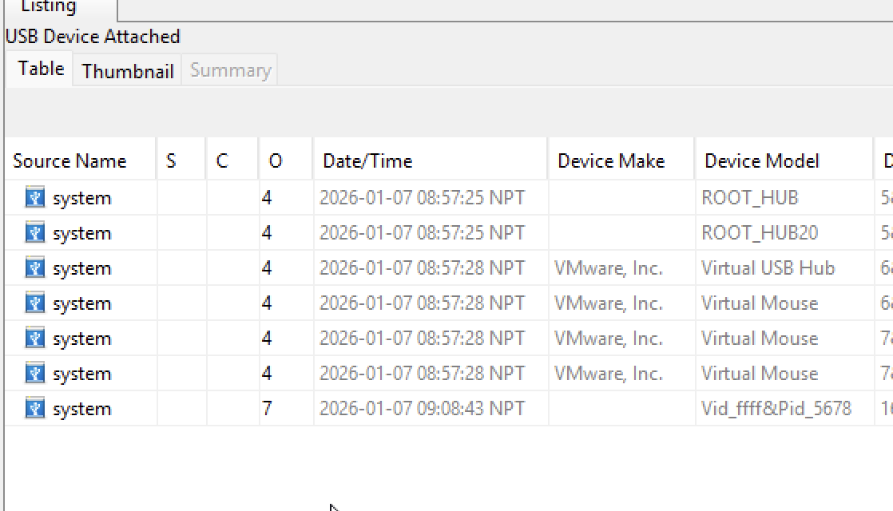  - Data Artifacts > USB Device Attached
Perform data carving | Yes | 01/01/2026 | 12:33 pm | 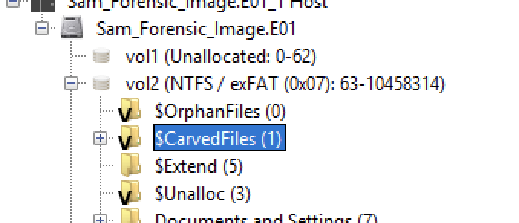  - Run PhotoRec Carver module > Carved Files
Run relevant keyword searches;  Did you index the evidence file? | Yes | 01/01/2026 | 12:50 pm | Reviewed the results under "Analysis Results > Keyword Hits > Single Literal Keyword Search."  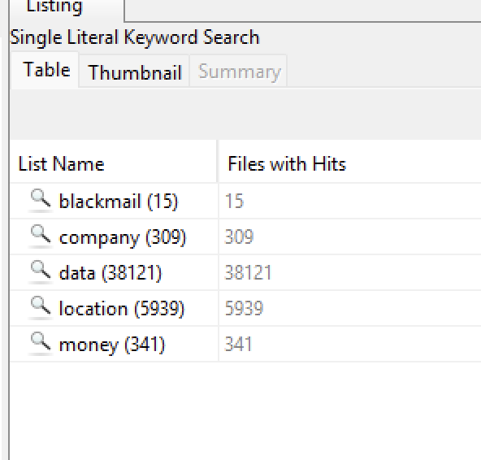
Recover Log-on passwords –  use SAMInside/Ophcrack/Encase | Yes | 01/01/2026 | 1:10 pm | 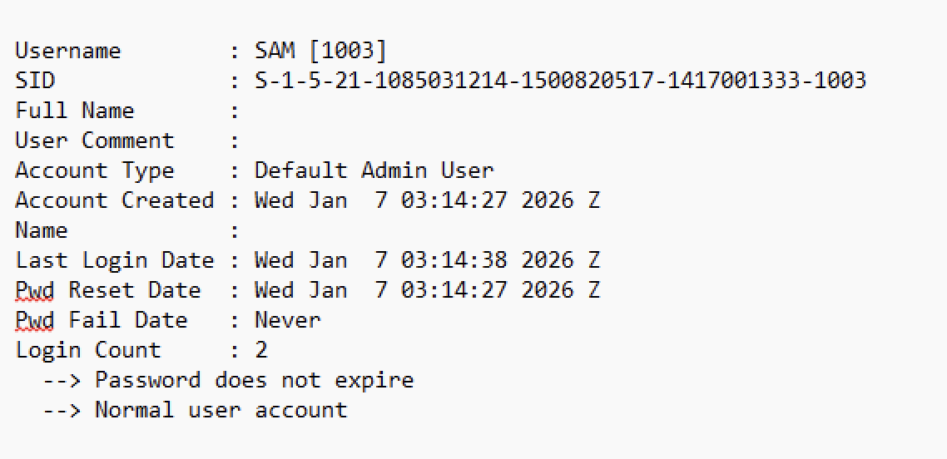  - SAM file was previously analyzed. No password is required for the login.
Examine different file types:  Export doc/office and exe files; look at Metadata if required | Yes | 01/01/2026 | 1:17 pm | - File Types > Metadata  - Metadata of Multiple images were analysed.  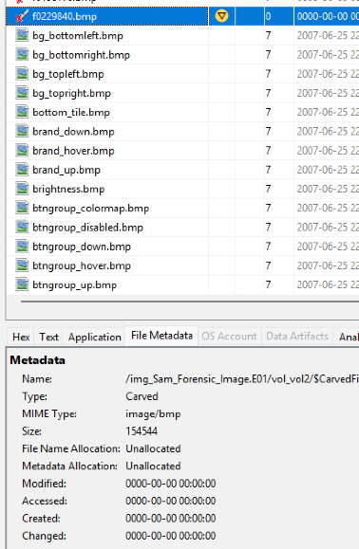  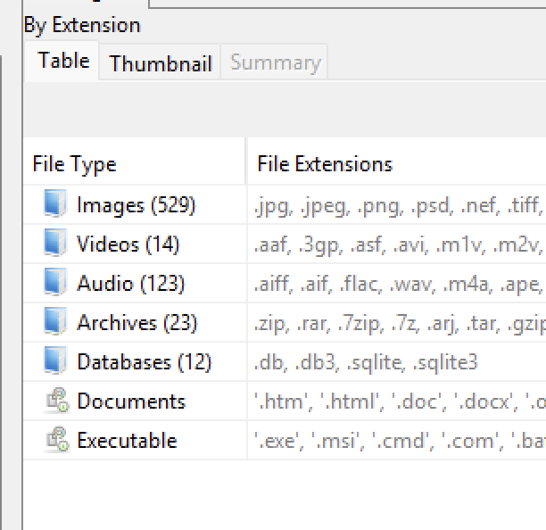
Encryption, Steganalysis (any indications? Entropy or Autopsy can be used) | Yes | 01/01/2026 | 1:35 pm | - Click: Analysis Reports> Encryption Suspected  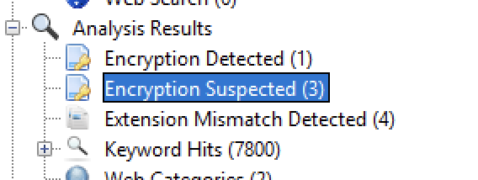  - A image was suspected to have stenography so I extracted the image and using powershell I used string.exe and checked the image there was a message in image command used: string.exe /friend.jpg  Path: ".WINDOWS/Documentsandsettings/SAM/Documents/friend.jpg  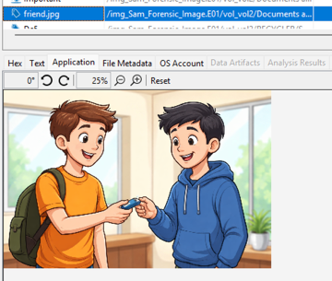  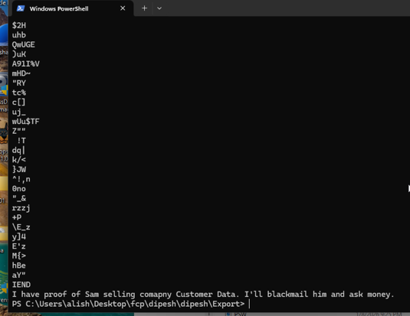
Print artefacts | Yes | 01/01/2026 | 2:00 pm | - Investigated /Windows/System32/spool/PRINTERS/ and searched entire image for .spl and .shd files.  No evidence of print spool files found.  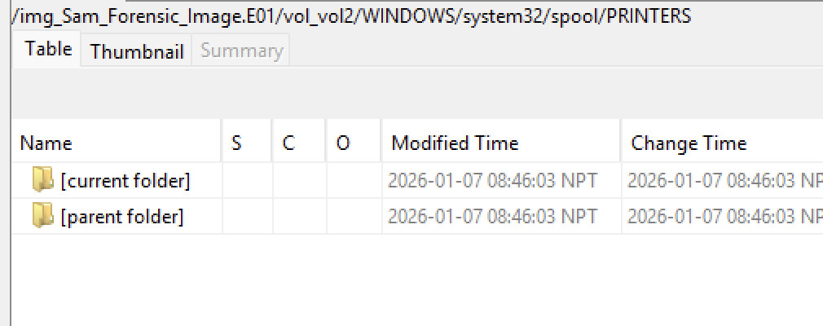  - Keyword searches for printer, .spl, and spool returned 0 relevant hits.
CD/DVD burning apps; check log files | Yes | 01/01/2026 | 2:10 pm | 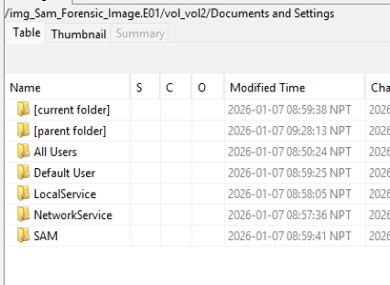  - Analysed Path: /Documents and Settings/  - No such events were present in the image.
Validate evidence integrity at the end of the examination | Yes | 01/01/2026 | 3:00 pm | 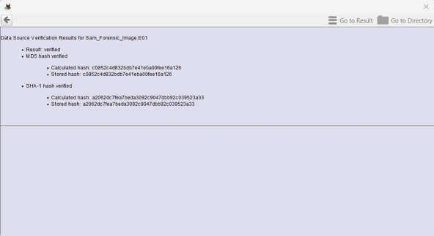  - Hash values are consistent, indicating an examination conducted without data tampering.  - Ran the Ingest module to verify Data Source Integrity.

Additional Notes/Artefacts Examined:

Colour-coding Legend | Tasks
 | Fundamental
 | Basic
 | Elementary
 | Secondary
 | Advanced
 | Exceptional

